CODE FOR MongoDB CRUD Operatins:
package anotherNewProject;

import com.mongodb.client.*;
import com.mongodb.client.model.Filters;
import com.mongodb.client.model.Updates;
import org.bson.Document;

public class MongoCRUDExample {

public static void main(String[] args) {

// Connect to MongoDB
MongoClient mongoClient = MongoClients.create("mongodb://localhost:27017");

// Access database
MongoDatabase database = mongoClient.getDatabase("CollegeDB");

// Access collection
MongoCollection<Document> collection =
database.getCollection("Students");

// ==========================
// CREATE (Insert)
// ==========================
Document student = new Document("id", 101)
.append("name", "John")
.append("department", "CSE")
.append("cgpa", 8.7);

collection.insertOne(student);
System.out.println("Document Inserted Successfully");

// ==========================
// READ (Find)
// ==========================
System.out.println("\nStudent Records:");

FindIterable<Document> students = collection.find();

for (Document doc : students) {
System.out.println(doc.toJson());
}

// ==========================
// UPDATE
// ==========================
collection.updateOne(
Filters.eq("id", 101),
Updates.set("cgpa", 9.2)
);

System.out.println("\nDocument Updated Successfully");

// ==========================
// READ Updated Record
// ==========================
Document updatedStudent =
collection.find(Filters.eq("id", 101)).first();

System.out.println("\nUpdated Record:");
System.out.println(updatedStudent.toJson());

// ==========================
// DELETE
// ==========================
collection.deleteOne(Filters.eq("id", 101));

System.out.println("\nDocument Deleted Successfully");

// Close connection
mongoClient.close();
}
}

OUTPUT:
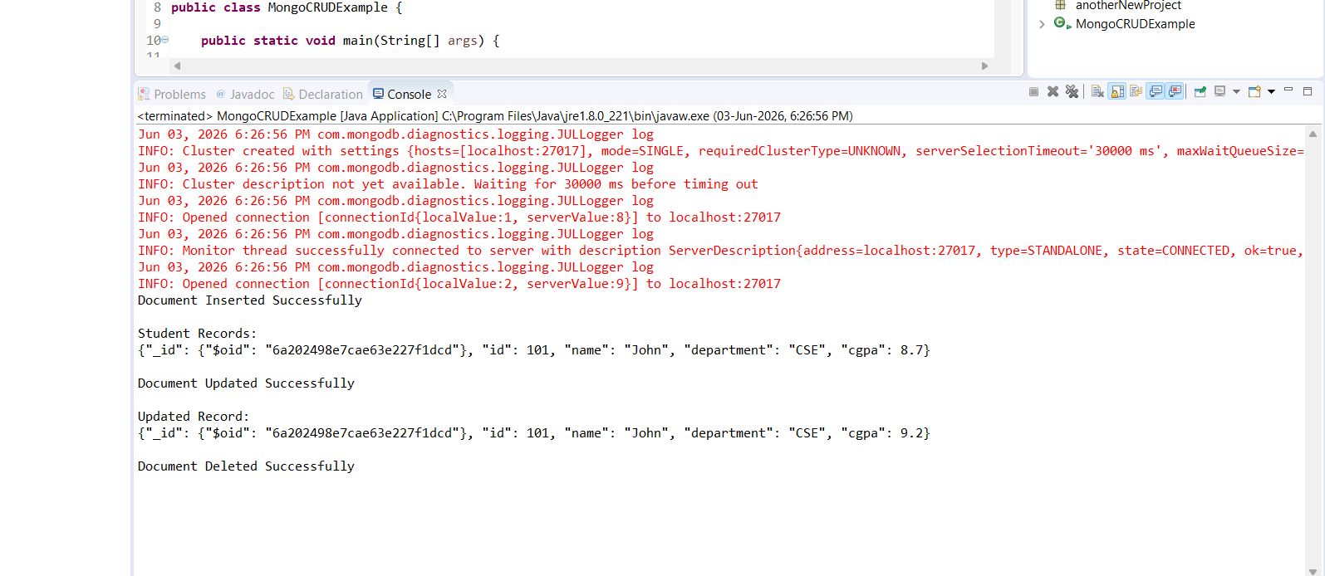
MODIFIED:
Code:
package anotherNewProject;

import com.mongodb.client.*;
import com.mongodb.client.model.Filters;
import com.mongodb.client.model.Updates;
import org.bson.Document;

public class MongoCRUDExamplenew {

public static void main(String[] args) {

MongoClient mongoClient =
MongoClients.create("mongodb://localhost:27017");

MongoDatabase database =
mongoClient.getDatabase("CollegeDB");

MongoCollection<Document> collection =
database.getCollection("Students");

// ==========================
// CREATE
// ==========================
Document student = new Document("id", 102)
.append("name", "Rudradeep")
.append("department", "CSE CORE DEPT")
.append("cgpa", 9.48)
.append("city", "Guwahati");

collection.insertOne(student);

System.out.println("Document Inserted Successfully");

// ==========================
// READ
// ==========================
System.out.println("\nCSE CORE Students:");

FindIterable<Document> students =
collection.find(
Filters.eq("department", "BCE"));

for (Document doc : students) {
System.out.println(doc.toJson());
}

// ==========================
// UPDATE
// ==========================
collection.updateOne(
Filters.eq("id", 102),

Updates.combine(
Updates.set("cgpa", 9.26),
Updates.set("department", "DEV OPS")
)
);

System.out.println("\nDocument Updated Successfully");

// ==========================
// READ UPDATED RECORD
// ==========================
Document updatedStudent =
collection.find(
Filters.eq("id", 102))
.first();

System.out.println("\nUpdated Record:");

if (updatedStudent != null) {
System.out.println(updatedStudent.toJson());
}

// ==========================
// DELETE
// ==========================
collection.deleteOne(
Filters.eq("id", 102));

System.out.println("\nDocument Deleted Successfully");

// Close Connection
mongoClient.close();
}
}
OUTPUT:
